# Lesson 64 单词讲解

1. port n. 港口

airport n. 空港，飞机场

1. ventilate v. 通风

well-ventilated adj. 通风良好的

ventilation n. 通风

1. invasion n. 入侵，侵略

This is the invasion of my privacy. invade v. 入侵，侵略，侵袭

Hitler invaded Poland in September, 1939.

1. officially adv. 正式地，官方地

Officially, the election campaign will begin in July. The gallery was officially open last month.

1. connect v. 连接

connect … to / with …

The bridge connected this small town to the big big city. connection n.

1. European adj. 欧洲的，欧洲人的 n. 欧洲人

European continent 欧洲大陆

European Union 欧盟

Europe n. 欧洲

euro n. 欧元

1 tunnel ['tʌnl] n.隧道

2 port [pɔ:t] n.港口

3 ventilate ['ventileit] v.通风

4 chimney ['tʃimni] n.烟囱

5sea level 海平面

6 double ['dʌbəl] a.双的

7 ventilation [ˌventi'leiʃən] n.通风

8 fear [fiə] v.害怕

9 invasion [in'veiʒən] n.入侵，侵略

10 officially [ə'fiʃəli] ad.正式地

11 connect [kə'nekt] v.连接

12 European [juərə'pi:ən] a.欧洲的

13 continent['kɔntinənt] n.大陆

# Lesson 64 课文&语法讲解

本课重点:

if 非真实条件句（虚拟）--假设过去宾语从句的虚拟

1. In 1858, a French engineer… arrived in England with a plan for a twenty-one-mile tunnel under the English Channel.

简单句同位语

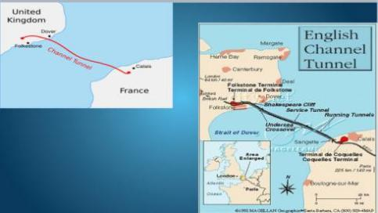with a plan for a … tunnel …

1. He said that it would be possible to build a platform in the centre of the Channel.

that 引出宾语从句to do 真正的主语it 形式主语

1. The tunnel would be well-ventilated if tall chimneys were built above sea level.

真实条件句

4.In 1860, a better plan was put forward by an Englishman...

put forward 提前，提出put forward a plan / proposal put forward some new ideas

1. He suggested that a double railway-tunnel should be built. suggest 表示“建议”，其后宾语从句要虚拟

从句中谓语动词 = （should）+ 动词原形

表示“建议／命令／要求”，其后宾语从句都要虚拟：

suggest, advise, propose, recommend ／order／ask, demand, insist, request …

The engineers proposed that they should look (look) at the design again.

The professor recommended we should look (look) for the information in the library.

表示“建议／命令／要求”，其后宾语从句都要虚拟：

suggest, advise, propose, recommend ／order／ask, demand, insist, request …

The teacher always suggests the students should (go) over the text before the test. The workers demanded they should be given (give) the wages they should get.

1. This would solve the problem of ventilation, for if a train entered this tunnel, it would draw in fresh air behind it.

Draw in 拉进来

If 虚拟条件句假设现在

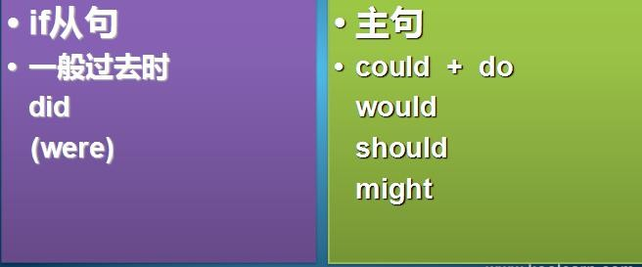

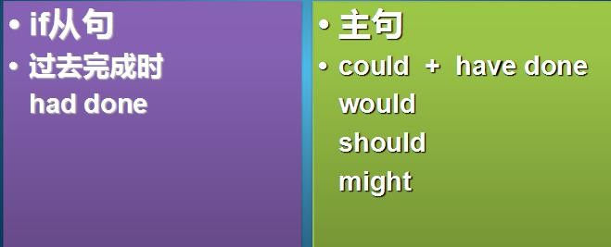If 虚拟条件句假设过去

if 非真实条件句（虚拟）--假设过去

Years ago if someone had turned round to me and said “ in two years you’ ll be England captain”,

I would have turned round and said, “I don’t think so!”

1. 如果不是因为那时英国人害怕入侵，隧道早已建成了。if 非真实条件句（虚拟）

假设过去

If, at the time, the British _had not feared_ (fear) invasion, it ~~would have completed~~_ (complete).

would have been completed

if 非真实条件句（虚拟） 假设过去

I didn’t tell her the result. She didn’t know it. If I …, …

If I had told her the result, she would have known it. if 非真实条件句（虚拟）

假设过去

He was not a student, so he couldn’t attend the lecture.

If he …, …

If he had been a student, he could have attended the lecture. if 非真实条件句（虚拟）

假设过去

We were late, so we missed the appointment. If we …, …

If we had not been late, we would not have missed the appointment.

If 虚拟条件句假设将来

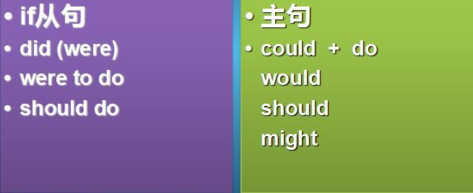

if 非真实条件句（虚拟） 假设将来

1. If I were to live my life over again, I would have you as my wife.
2. It was officially opened on March 7,1994, finally connecting Britain to the European continent.

connecting 非谓语动词

本课重点:

if 非真实条件句（虚拟）--假设过去宾语从句的虚拟

# Lesson 64 知识拓展

本课重点:

if 非真实条件句（虚拟）--假设过去

If 虚拟条件句假设过去

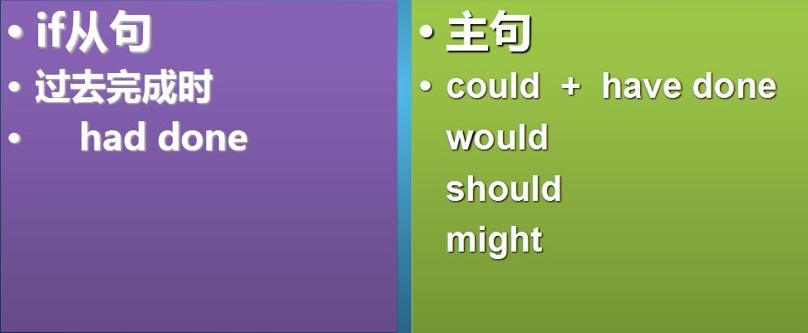

如果不是因为那时英国人害怕入侵，隧道早已建成了。

if 非真实条件句（虚拟） 假设过去

If, at the time, the British had not feared invasion, it would have been completed.

if 非真实条件句（虚拟）--假设过去

If you had told me about it earlier, I (be) able to help you.

would have been

if 非真实条件句（虚拟）--假设过去

If you (come) with us, we would have been more pleased. had come

if 非真实条件句（虚拟）--假设过去

You (not make) such a mistake if you had been more careful. would not have made

if 非真实条件句（虚拟）--假设过去

Policeman: Why didn’t you shout for help when you were robbed of your watch?

Man: If I had opened my mouth, they would have found my four gold teeth. That would be much worse.

本课重点:

if 非真实条件句（虚拟）--假设过去